OFFSHORE JUMBO PISTON CORE SAMPLING PROTOCOL

- Before the core is deployed, the liner is labeled with Job #, Core ID, Sections and vertical arrow point to top of core liner. The sections are labeled from the bottom of the liner with the letter A proceeding alphabetically towards the top of the liner.

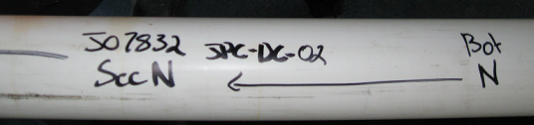

- Upon core retrieval, make first cut above the mud line and cap.

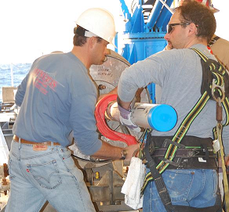

- Make a next cut at the next 1-yard (or meter) section mark, slice through mud with wire saw, and cap.

- Securely tape the bottom end cap to the liner with BLACK electrical tape.

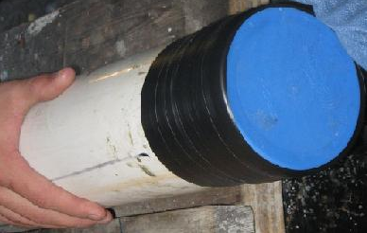
- Carefully carry the initial section to its holder in the lab room and store vertically.

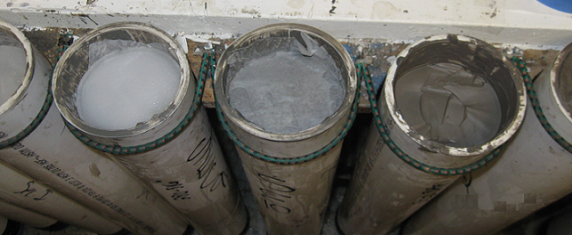

- Using the outside-puller tool and electric winch, pull liner assy out from the core head a 1-yard (or meter) section at a time.
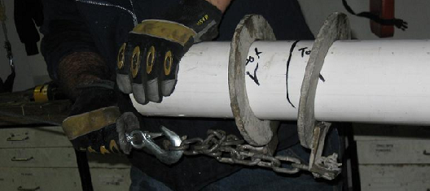

- Make a cut at the next 1-yard (or meter) section mark, slice through the mud with wire saw, and cap.

- Securely tape the bottom end cap to the liner with BLACK electrical tape.

- Carefully carry the section to its holder in the lab van. Repeat this step for each of the sections inside the core rig.

- All excess water and debris is removed from core liner using paper towels.

- The cores sections are relabeled numerically on the liner once in the lab. The shallowest section with the highest letter is labeled as section 1, Top depth, Bottom Depth, and date with an arrow pointing to the top of the section on both sides of the liner.

- Each section is relabeled such that letter A is now the highest number.

- The top cap of each section is labeled with Job #, Core ID, Section #, depth, and date.

- A digital picture of the top of each section and cap is taken by holding the cap level with the core section. Use the close up option (the option is labeled with a flower on the camera) without flash to prevent glare (see example).

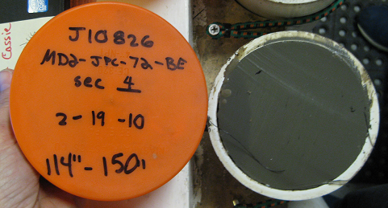

- A visual description is recorded, noting water content, cohesion, forams, and color (using Munsell color chart). Also record any other observations in the comments section (i.e. odors, minor liner damage, etc.)

- If requested by client: Torvane and minivane testing are conducted at the top of each section and the bottom of the last section.

- If requested by client: The tested soil (or at least 3” of sediment) is removed from the core and placed in a bag labeled with Job #, Core ID, Section #, depth of removed soil (ex. 3’-3’4”), and date.

- If there is an empty space in the liner, ensure there is a level surface at the top of the sediment. If there is not, make the surface level by gently removing the smallest amount of sediment possible using a spatula. Minimize disturbance of the sediment.

- If requested by client: A square piece of wax paper is placed in the core at the depth of the removed soil, then hot wax is poured on the wax paper and allowed to cool.

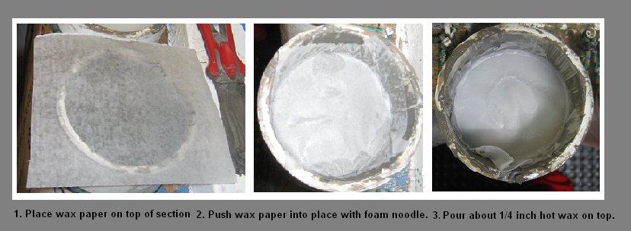

- Foam noodle tube is placed on top of the cooled wax and cut even with the top of the liner to prevent shifting of the sample. Do not force the sediment down into the liner.

- The top cap is placed on each section and securely tapped with WHITE electrical tape.

- The core sections are stored and secured in a vertical position with the deep portion of the section on the bottom (White electric tape at the top).

